Lists in dart

Workshop #3

Flutter Developer Bootcamp

# **Purpose**

This workshop demonstrates the basic operations on lists in Dart programming language.The code showcases basic list manipulation operations such as adding, removing, and checking for the presence of elements. It's a simple example demonstrating how to work with lists in Dart.

# **Problem**

In the given workshop, there will be a list of your favorite animal([‘cat, ‘Dog’, ‘Lion, ‘Tiger’] and also have Remove function to remove an animal from the list(example removing dog). You need to add a new animal ‘Cheetah’ to the list and also check if the list contains a ‘Cat’ is it true or false(bool condition).

**How to Solve**

1. Checkout the workshop from Git Repo:

git clone -b <user-branch> <repo-URL>

1. Open the root folder inside VS Code
2. Open the root folder in terminal
3. Run the command dart run filename.dart
4. Add a new animal to the list.
5. Check if the list contains a specific animal.
6. Go To File: <specific-file-with-list-method> à <method-name>, implement your logic.

**You will Achieve**

When you complete this workshop you will learn the following:

* **List Creation:**

A list named favoriteAnimals is defined to store strings representing favorite animals. It's initialized with four animals: 'Cat', 'Dog', 'Lion', and 'Tiger'.

* **Printing the List:**

The content of the list favoriteAnimals is printed using the print() function.

* **Adding an Element to the List:**

The add() method is used to append the string 'Cheetah' to the favoriteAnimals list.

* **Removing an Element from the List:**

The remove() method is used to remove the string 'Dog' from the favoriteAnimals list.

* **Checking if an Element is in the List:**

The contains() method is used to check if the string 'Cat' is present in the favoriteAnimals list. The result is stored in the variable containsCat.

* **Printing Results:**

The results of each operation (adding, removing, and checking for the presence of an element) are printed using print() statements.

* **It showcases basic list operations in Dart:**
* Adding elements with add().
* Removing elements with remove().
* Checking for the presence of elements with contains().
* Printing the contents of a list with print().

# **Screenshots**

## **Before implementation (without adding favorite animal and checking a specific animal in list )**

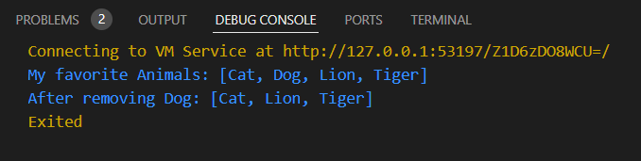

## **After implementation (With adding favorite animal and checking specific animal in list)**

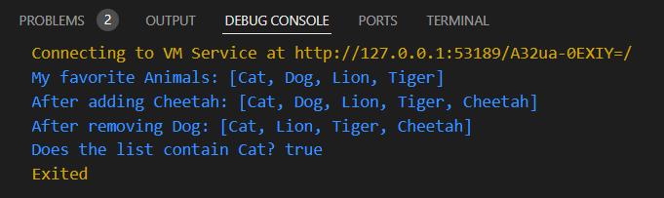

# **How to submit your workshop**

Push your project back to the same git branch using command:

<command name>

# **Happy Coding!**